Is It Macro or Micro? AAG-2017 Answers

1. | 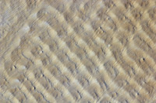 | MACRO – approximately 18 km by 11.5 km.  Sand dunes in the Erg of Bilma (Ténéré Niger). Normal color digital camera image from the International Space Station. Image taken December 1, 2009.  Image from NASA’s International Space Station Photo Library.
2. |  | MICRO – Fall, 2011. Width of image approximately 300 µm.  Skin of a Leopard Frog. Colorized scanning electron microscope image.  Imaged and processed by P. Kelly.
3. |  | MACRO – Approximately 25 km by 20 km  Siberian Tundra - Landsat ETM bands 542 RGB color composite (shortwave-infrared, near-infrared, green spectrum), image taken: July 27, 2000.  Raw data from Global Land Cover Facility, processed by S. Young.
4. |  | MICRO – Fall, 2011. Width of image approximately 300 µm.  Polished Garnet. Colorized scanning electron microscope image.  Imaged and processed by P. Kelly.
5. | 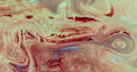 | MACRO – Approximately 56 km by 27 km  Dasht-e Kavir Desert region in Iran. The redder the color the warmer the earth. Landsat ETM bands 641 RGB color composite (Thermal-infrared, Near-infrared, blue spectrum), image taken: August 19, 2005.  Raw Data from Global Land Cover Facility, processed by S. Young.
6. | 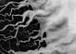 | MACRO – 15 November 1999. Approximately 100 km by 70 km.  This is a Landsat ETM image of the Ganges-Brahmaputra Delta (11-15-1999). An RGB 741 image was created and converted into a black & white image.  Raw data downloaded from Global Land Cover Facility and processed by S. Young.
7. |  | MICRO – Fall, 2011. Width of image approximately 1 mm.  Dermal bone of an Atlantic Sturgeon, Acipenser oxyrhynchus. Scanning electron microscope image.  Imaged and processed by P. Kelly.
8. |  | MICRO – Fall, 2011. Width of image approximately 4 mm.  Threads of a small screw. Scanning electron microscope image.  Imaged and processed by P. Kelly.
9. |  | MICRO – Fall, 2011. Width of image approximately 300 µm.  Developing eye of a larval Zebrafish, Danio rerio. Colorized scanning electron microscope image.  Imaged and processed by P. Kelly.
10. | 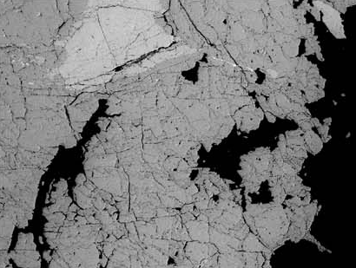 | MICRO – Fall, 2011. Width of image approximately 300 µm.  Polished mineral surface. Colorized scanning electron microscope image.  Imaged and processed by P. Kelly.
11. |  | MACRO – 16 April, 2001. approximately 15 km by 12 km.  Digital photograph of deforestation associated with the Tierras Bajas project in eastern Bolivia, taken by astronauts from the International Space Station.  Image downloaded from the Johnson Space Center.
12. | 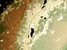 | MICRO – Fall, 2011. Width of image approximately 5 mm.  Polished mineral surface. Colorized scanning electron microscope image.  Imaged and processed by P. Kelly.
13. | 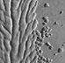 | MACRO – 4 September, 2010. approximately 10 km by 10 km  Natural-color image of the Matusevich Glacier (East Antarctica) captured by the Advanced Land Imager (ALI) on NASA’s Earth Observing-1 (EO-1) satellite.  Original image: NASA Earth Observatory image created by Jesse Allen and Robert Simmon, using EO-1 ALI data provided courtesy of the NASA EO-1 team.
14. | 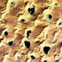 | MACRO – 29 September, 2005. approximately 14 km by 14 km.  This is a Proba satellite (CHRIS sensor) image of small, ground-water fed lakes in the Gobi Desert in China’s Inner Mongolia. The lakes are surrounded by some of the tallest dunes in the world.  Data downloaded from the European Space Agency. Additional processing by SYoung.
15. | 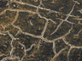 | MICRO – Fall, 2011. Width of image approximately 150 µm.  Surface of a Corn Snake (Pantherophis guttata) eggshell. Colorized scanning electron microscope image.  Imaged and processed by P. Kelly.
16. |  | MACRO – 27 July, 2010. Approximately 1.5 km by 0.75 km.  White lines in the Gobi desert in China. Image captured by the IKONOS sensor, July 27, 2010.  Image downloaded from Satellite Image Corporation.
17. |  | MACRO – Approximately 29 km by 17 km  Melting ice in Antarctica  Landsat ETM panchromatic Band 8 (visible spectrum), image taken: February 21, 2000.  Raw data from Global Land Cover Facility, processed by S. Young.
18. | 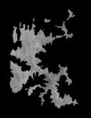 | MACRO – 27 July, 2010. Approximately 28 km by 36 km.  Ash Shishah, Musandam peninsula, Oman. Landsat ETM panchromatic Band 8 (visible spectrum) image.  Raw Data from Global Land Cover Facility, processed by S. Young.
19. |  | MICRO – Fall, 2015. Width of image approximately 500 µm.  Shell of a sea urchin, Arbacia punctulata. Colorized scanning electron microscope image.  Imaged and processed by P. Kelly.
20. | 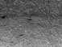 | MICRO – Fall, 2011. Width of image approximately 500 µm.  Polished aluminum surface. Scanning electron microscope image.  Imaged and processed by P. Kelly.
21. | 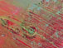 | MACRO – 10 August 2001. Approximately 80 km by 60 km.  This is a Landsat image from Mali, north Africa with red indicating heat.  Raw data downloaded from Global Land Cover Facility and processed by S. Young.
22. |  | MACRO – Approximately 48 km by 40 km  Dry Salt Lakes (Inggarda, Western Australia). Landsat ETM panchromatic Band 8 (visible spectrum), image taken: May 24, 2006.  Raw data from Global Land Cover Facility, processed by S. Young.
23. |  | MACRO – Approximately 18 km by 12 km  Sand dunes in Grand Erg Oriental Desert, Algeria. This is a Landsat TM RGB 742 image (mid-infrared, near infrared, and green visible spectrum). Image is a composite of Landsat images from the 1990’s.  Landsat TM data acquired through NASA's Earth Science Applications (ESA) Directorate at Stennis Space Center. Image processed by S. Young.
24. | 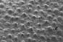 | MICRO – Fall, 2011. Width of image approximately 1 mm.  Skeleton of a coral. Scanning electron microscope image.  Imaged and processed by P. Kelly.
25. | 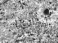 | MICRO – Fall, 2011. Width of image approximately 500 µm.  House Sparrow (Passer domesticus) lung tissue.  Imaged and processed by P. Kelly.
26. | 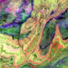 | MACRO – 13, June, 2001. Approximately 28 km by 29 km.  This is an ASTER image of the Atlas mountains of Morocco.  Image downloaded from NASA's Earth Observatory and processed by S. Young.
27. | 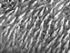 | MICRO – Fall, 2011. Width of image approximately 400 µm.  Surface of the tongue of a Leopard Frog (Lithobates pipiens). Scanning electron microscope image.  Imaged and processed by P. Kelly.
28. |  | MACRO - 74 km by 52 km  Lena River Delta (Siberia, Russia). Landsat ETM panchromatic Band 8 (visible spectrum), image taken: June 30, 2000.  Raw data from Global Land Cover Facility, processed by S. Young.
29. | 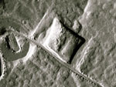 | MICRO – Fall, 2016. Width of image approximately 700 µm.  Sodium Chloride crystal. Scanning electron microscope image.  Imaged and processed by P. Kelly.
30. | 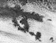 | MACRO – 7 August, 2002, approximately 1100 km by 850 km  This is a true-color Moderate Resolution Imaging Spectroradiometer (MODIS) image of cumulus clouds captured over the eastern South Pacific Ocean.  Image created by Jacques Descloitres, MODIS Land Rapid Response Team, NASA/GSFC, additional image processing, S. Young.
31. | 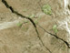 | MICRO – Fall, 2011. Width of image approximately 500 µm.  Surface of a rotted human tooth. Colorized scanning electron microscope image.  Imaged and processed by P. Kelly.
32. | 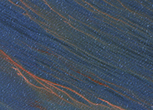 | MACRO – Approximately 1.4 km by 1 km  Deepwater Horizon Oil Spill (Gulf of Mexico).  GeoEye-1 Satellite image, taken: April 29, 2010.  Image from Satellite Image Corporation.
33. |  | MICRO – Fall, 2016. Width of image approximately 300 µm.  Surface of the tooth of a Whitetail Deer (Odocoileus virginiana). Colorized scanning electron microscope image.  Imaged and processed by P. Kelly.
34. |  | MACRO - 176 km by 130 km  Manicouagan Crater (Quebec, Canada)  Landsat ETM bands 542 RGB color composite (near-infrared, near-infrared, green spectrum), printed in black & white, images take: June 30, 2000.  Raw data from Global Land Cover Facility, processed by S. Young.
35. | 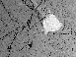 | MICRO – Fall, 2011. Width of image approximately 3 mm.  Polished aluminum surface. Scanning electron microscope image.  Imaged and processed by P. Kelly.
36. |  | MICRO – Fall, 2011. Width of image approximately 3 mm.  Surface of the wing of a Blue Darner Dragonfly (Aeshna multicolor). Colorized scanning electron microscope image. Colorized for beauty – not science.  Imaged and processed by P. Kelly.
37. | 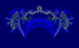 | MACRO – 7 December 1994. Approximately 120 km by 70 km.  Okay, this is a manipulated image of the Mississippi River delta, a mirror imaged of the delta. Originally a Landsat TM normal color image.  Raw data downloaded from Global Land Cover Facility and processed by S. Young.

